A
PROJECT REPORT
ON

(Skill Assessment and Career Guidance Website)
SUBMITTED BY
Prachi Kanani
And
Prathana Dama
ACADEMIC YEAR 2026-27
T.Y. B.C.A. SEM - 5
UNDER THE GUIDANCE OF
Mr. Yash Kotecha
SMT. C.Z.M. GOSRANI B.C.A. COLLEGE
JAMNAGAR
SUBMITTED TO

SAURASHTRA UNIVERSITY
RAJKOT

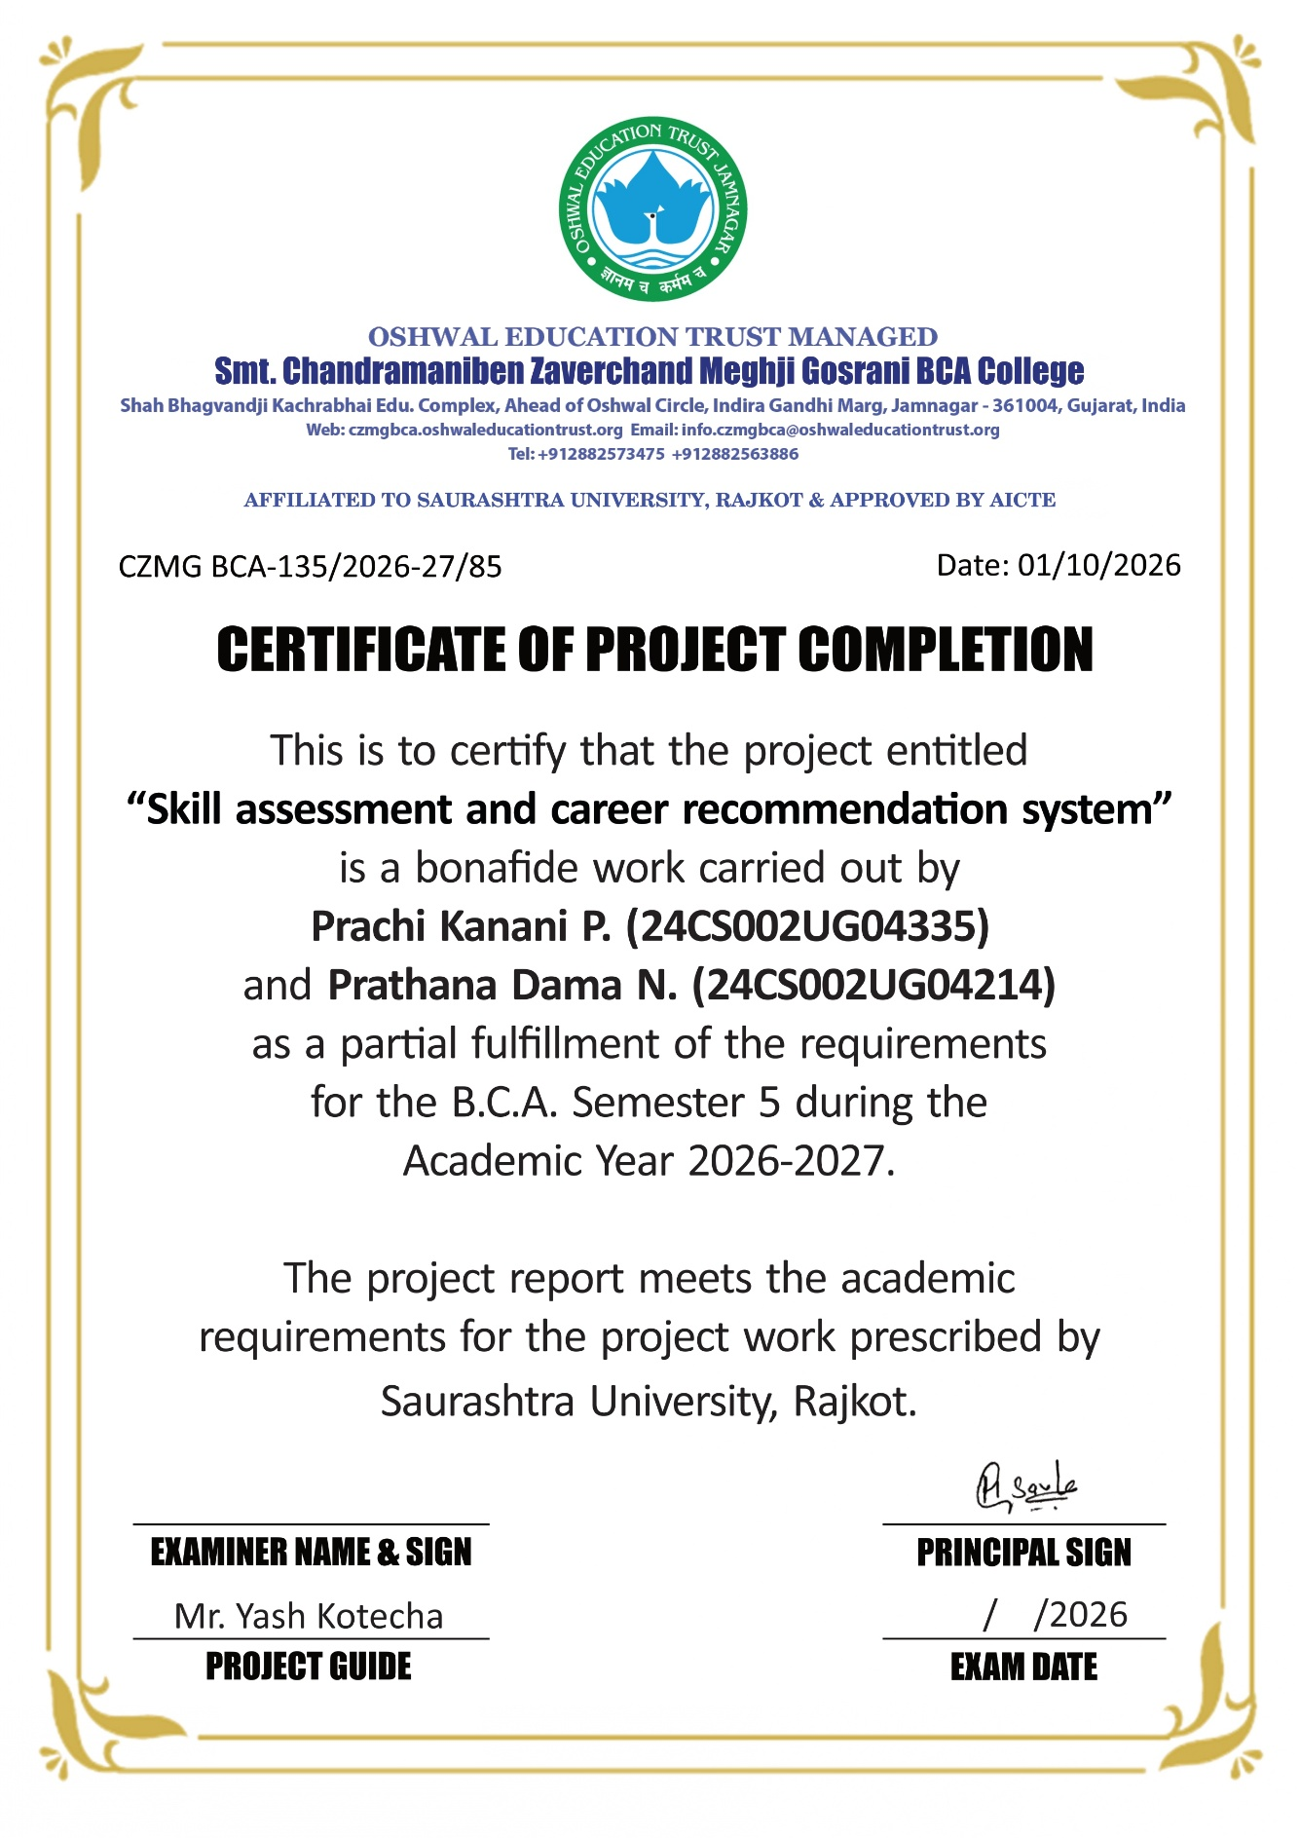

INDEX
Sr. No. | TITLE | Page No.
 | TITLE PAGE | I
 | ABSTRACT | II
 | ACKNOWLEDGEMENT | III
 | PROJECT PROFILE | IV
1 | SDLC OVERVIEW | 1
2 | REQUIREMENT GATHERING AND ANALYSIS | 2
 | 2.1 Organization Details | 2
 | 2.2 Meetings | 2
 | 2.3 Data which will be Input into the System | 3
 | 2.4 Data which will be Output from the System | 3
 | 2.5 Type of Project | 3
 | 2.6 Method of Collecting Data | 3
3 | SYSTEM REQUIREMENT SPECIFICATIONS | 4
 | 3.1 Introduction | 4
 | 3.1.1 Purpose | 4
 | 3.1.2 Intended Audience and Reading Suggestions | 4
 | 3.1.3 Scope | 4
 | 3.2 Overall Description | 4
 | 3.2.1 Product Function | 4
 | 3.2.2 User Classes and Characteristics | 5
 | 3.2.3 Operating Environment | 5
 | 3.2.4 Design and Implementation Constraints | 5
 | 3.2.5 Assumptions and Dependencies | 6
 | 3.3 External Interface Requirement | 6
 | 3.3.1 User Interface | 6
 | 3.3.2 Software Interface | 6
 | 3.4 System Features | 6
 | 3.5 Other Non-functional Requirements | 7
 | 3.5.1 Performance Requirement | 7
 | 3.5.2 Security Requirement | 7
 | 3.5.3 Safety Requirement | 7
 | 3.6 Feasibility Study | 7
 | 3.6.1 Operational Feasibility | 8
 | 3.6.2 Technical Feasibility | 8
 | 3.6.3 Economic Feasibility | 8
 | 3.6.4 Schedule Feasibility | 8
4 | SYSTEM ANALYSIS AND MODELING | 9
 | 4.1 Use Case Diagram | 9
 | 4.2 Normalization | 11
 | 4.3 E-R Diagram | 17
 | 4.4 Data Dictionary | 18
 | 4.5 Functional and Behavior Modeling | 21
 | 4.5.1 Context Diagram (0-Level Diagram) | 21
 | 4.5.2 First Level Diagram (1-Level Diagram) | 22
 | 4.6 Gantt Chart | 25
5 | TEST CASES | 26
6 | SCREENSHOTS | 30
 | 6.1 Home Page | 30
 | 6.2 Student Registration Page | 30
 | 6.3 Login Page | 31
 | 6.4 Student Dashboard Page | 31
 | 6.5 Student Assessment Page | 32
 | 6.6 Student Career Explorer Page | 32
 | 6.7 Student Assessment Result Page | 33
 | 6.8 Student Career Dashboard Page | 33
 | 6.9 Student Recommended Career Page | 34
 | 6.10 Student Assessment History Page | 34
 | 6.11 Student Profile Page | 35
7 | CODE EXPLANATION | 36
 | 7.1 Database Configuration | 36
 | 7.2 Login Page | 37
 | 7.3 Privacy Page | 38
 | 7.4 Index Page | 39
 | 7.5 Logout Page | 40
8 | LIMITATIONS AND FUTURE ENHANCEMENT | 41
9 | CONCLUSION | 42
10 | REFERENCES AND BIBLIOGRAPHY | 43

ABSTRACT
NextPath is a Career Guidance and Skill Assessment web application which aims to help students identify suitable career opportunities based on their interests, aptitude and skills. Presently, students often face difficulty in choosing the right career due to lack of proper guidance and awareness about various career options.
In the proposed system, students can take a skill assessment test, and based on their responses, the system analyzes their strengths and recommends suitable career paths. The application also provides detailed information about different careers and related courses, enabling students to make informed decisions about their future.
ACKNOWLEDGEMENT
The feeling of gratefulness to anyone's help directly arises from the bottom of the heart. A small but important and timely help can prove to be a milestone in one's life.
This project is dedicated to all the people whom we met, took guidance from, talked to, interviewed and learned something from. On this occasion we sincerely thank all of them while submitting this project report.
We would like to thank Mr. Yash Kotecha for giving time-to-time valuable guidance during the project, and for guiding us in taking our curriculum decisions and in choosing, initiating and carrying out the project.
We have always felt the invisible help of the Almighty; without the blessings of the Almighty, we could not have succeeded.
Prachi Kanani
Prathana Dama
PROJECT PROFILE
DEVELOPERS
Name | Enrollment Number
(1) Prachi Kanani  (2) Prathana Dama | (1) 24CS002UG04335  (2) 24CS002UG04214
PROJECT DETAILS
Name of Project | NextPath
Project Title | Skill Assessment and Career Recommendation System
Platform | Front End: HTML5, CSS3, JavaScript  Back End: PHP, MySQL
Duration | 3 Months
Team Size | 2
GUIDE INFORMATION
Name of Guide | Mr. Yash Kotecha

1. SDLC OVERVIEW
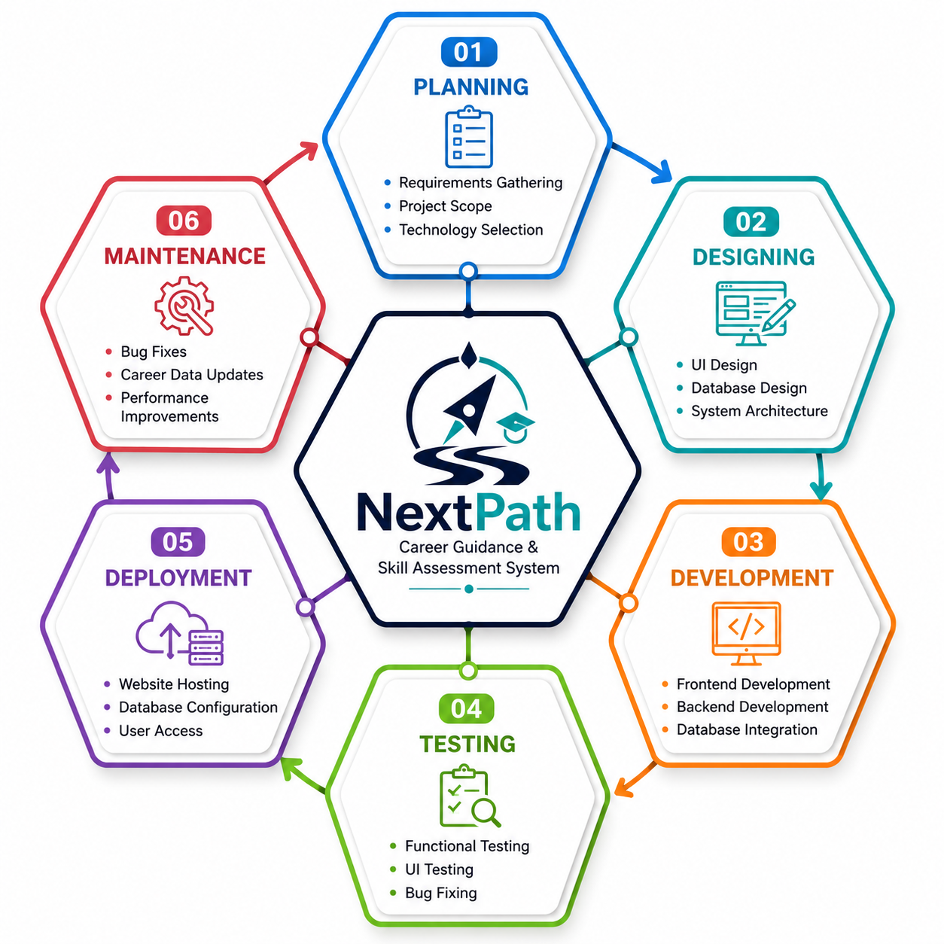
Figure 1.1: Software Development Life Cycle of NextPath
2. REQUIREMENT GATHERING AND ANALYSIS
2.1 Organization Details
1. Name of the Organization
NextPath Career Solutions Pvt. Ltd.
2. Brief Detail of the Organization
NextPath Career Solutions Pvt. Ltd. is an educational technology (EdTech) organization dedicated to helping students and career seekers make informed career decisions. The organization focuses on providing career guidance through aptitude assessment, interest evaluation and career exploration. Its mission is to bridge the gap between students' abilities and suitable career opportunities by offering a digital platform that delivers accurate career recommendations and detailed career information.
2.2 Meetings
I. Meeting with Project Coordinator
1. Name of Project Coordinator: Mr. Niraj Mehta
2. Project Coordinator's requirements in his words:
- Develop a secure web-based Career Guidance and Skill Assessment System.
- Allow users to register and log in securely.
- Conduct online skill assessments and analyze user responses.
- Generate career recommendations based on assessment performance.
- Display career and course information for users.
- Provide an admin panel to manage users, questions, categories, careers and courses.
- Ensure the system is user-friendly, responsive and easy to maintain.
II. Meeting with Users
1. Users:
- College Students
- Fresh Graduates
- Career Seekers
2. User requirements in their words:
- Simple and secure registration and login process.
- Easy-to-use skill assessment with clear questions.
- Career recommendations based on assessment performance and skills.
- Detailed information about careers and related courses.
- Easy access to assessment results and history.
- A user-friendly and responsive interface accessible on different devices.
- Secure storage of personal information and assessment records.
2.3 Data which will be Input into the System
- Student Registration Details
- Login Credentials
- Personal Information
- Educational Information
- Profile Update Information
- Interest Assessment Responses
- Career Assessment Responses
- Aptitude Test Responses
- Skill Assessment Responses
- Interests, Skills and Hobbies
- Career and Course Data entered by Administrator
- Assessment Questions and Categories managed by Administrator
2.4 Data which will be Output from the System
- Student Profile
- Assessment Score and Performance
- Career Analysis Report
- Career Assessment Results
- Career Information and Career Details
- Course Information related to Career Options
- Career Categories and Available Career Options
2.5 Type of Project
- Web-Based Online Application
2.6 Method of Collecting Data
- Interviews
- Questionnaires
- Career Research
- Internet Research
- Books and Educational Resources
3. SYSTEM REQUIREMENT SPECIFICATIONS
3.1 Introduction
3.1.1 Purpose
NextPath – Career Guidance and Skill Assessment System is a web-based application designed to assist students in identifying suitable career options based on their interests, aptitude and skills. The system provides an online assessment, analyzes the user's responses and recommends appropriate career paths along with detailed career information to help students make informed career decisions.
3.1.2 Intended Audience and Reading Suggestions
The intended audience of this document includes:
- Students
- Career Seekers
- Project Guide
- Developers
- System Administrator
3.1.3 Scope
The proposed system is a web-based Career Guidance and Skill Assessment platform that enables students and career seekers to register, complete an online skill assessment, view their assessment results and receive career recommendations based on their performance. The system also allows users to explore detailed information about various careers and related courses. An administrative panel is provided for managing users, assessment questions, categories, career information and course data.
3.2 Overall Description
3.2.1 Product Function
(i) Admin Module:
- Secure Admin Login
- Manage Student Records
- Manage Assessment Questions and Categories
- Add / Edit / Delete Career and Course Information
- View Assessment Records and Statistics
- Manage System Data
(ii) User Module:
- User Registration
- Secure Login
- Update Profile
- Take Skill Assessment
- View Assessment Results and Skill Profile
- View Recommended Careers
- Explore Career and Course Details
- View Assessment History
- Logout
3.2.2 User Classes and Characteristics
(i) User Classes:
- Administrator
- User / Student
(ii) User Characteristics:
(a) Administrator
- Manages assessment questions.
- Manages career and course information.
- Monitors student records and assessment data.
- Views system statistics and maintains system data.
(b) User / Student
- Can register and log in securely.
- Can complete the skill assessment.
- Can view assessment results and recommended careers.
- Can explore career and course information.
- Can update personal profile and view assessment history.
- Basic knowledge of using a web browser is sufficient.
3.2.3 Operating Environment
The application operates through an internet connection.
Hardware:
- RAM
Operating System:
- Windows
3.2.4 Design and Implementation Constraints
- English language interface.
- Internet connection required.
- Users must have basic computer or smartphone knowledge.
- Only administrators can modify career and assessment data.
- Secure login is required for all users.
3.2.5 Assumptions and Dependencies
- Administrator account already exists.
- Users have access to a web browser and required connection.
- PHP and MySQL are properly configured.
- Assessment questions, categories, career and course information are maintained by the administrator.
- Users are expected to provide accurate information and responses during registration and assessment.
3.3 External Interface Requirement
3.3.1 User Interface
The application provides a simple and interactive interface. Users can:
- Register
- Login
- Update Profile
- Take Assessment Test
- Submit Answers
- View Recommended Careers
- Explore Career and Course Details
- View Assessment History
- Logout
If incorrect login credentials are entered, an appropriate error message is displayed.
3.3.2 Software Interface
Component | Technology
Operating System | Windows
Front End | HTML5, CSS3, Bootstrap, JavaScript
Back End | PHP
Database | MySQL
Development Tool | Visual Studio Code (Version 1.69.0)
Web Server | Apache (XAMPP)

3.4 System Features
- User Registration
- Secure Login
- Profile Management
- Skill Assessment
- Assessment Result and Skill Profile
- Career Recommendation
- Career and Course Information
- Assessment History
- Admin Dashboard
- Question and Category Management
- Career and Course Management
- Student and Assessment Management
- System Statistics
3.5 Other Non-functional Requirements
3.5.1 Performance Requirement
- Fast response time.
- Smooth navigation between pages.
- Simple and user-friendly interface.
- Efficient database operations.
3.5.2 Security Requirement
- Secure user authentication and session management.
- Password protection and secure storage.
- Role-based access for Administrator and Student.
- Protection of user and assessment data.
- Input validation and secure database operations.
3.5.3 Safety Requirement
- Regular database backup.
- Protection against unauthorized data modification.
- Proper validation and handling of user data.
- Secure storage of important information.
- Error handling to prevent system failure.
3.6 Feasibility Study
A feasibility study evaluates whether the proposed system is practical, beneficial and capable of meeting user requirements within available resources.
3.6.1 Operational Feasibility
The NextPath system is simple and user-friendly. It allows students to complete career assessments, view results and explore career and course information. The administrative module helps manage students, assessments, careers and courses efficiently.
3.6.2 Technical Feasibility
The NextPath system uses available technologies such as HTML, CSS, JavaScript, PHP and MySQL. These technologies are suitable for developing and maintaining the web application.
3.6.3 Economic Feasibility
The project has low development cost as it uses open-source technologies and freely available tools. It also reduces manual effort in career assessment and information management.
3.6.4 Schedule Feasibility
The NextPath project can be completed within the allotted academic schedule. The selected technologies support timely development, testing and implementation.
4. SYSTEM ANALYSIS AND MODELING
4.1 Use Case Diagram
(a) Administrator Side
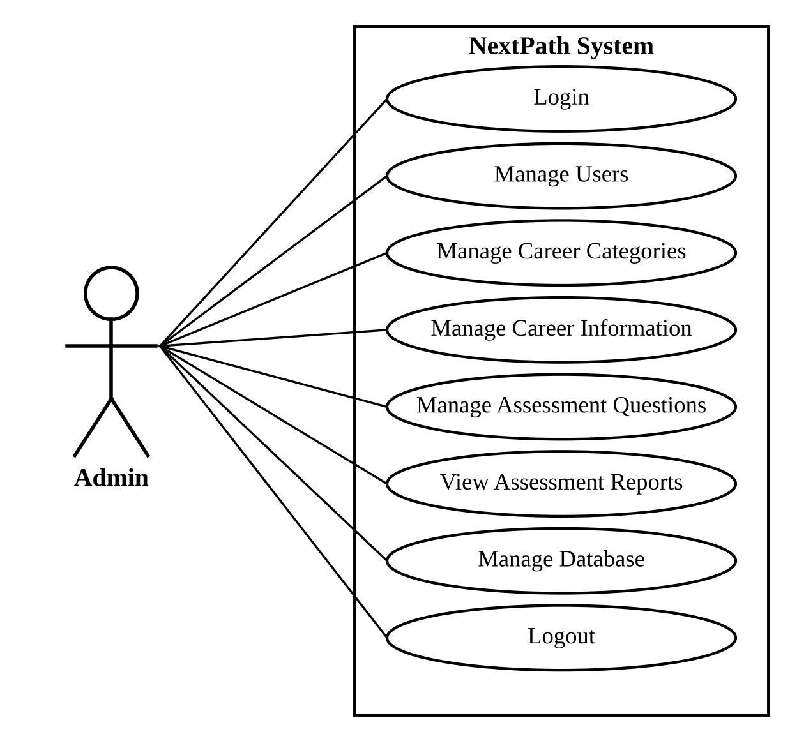
Figure 4.1: Use Case Diagram – Administrator
(b) User / Student Side
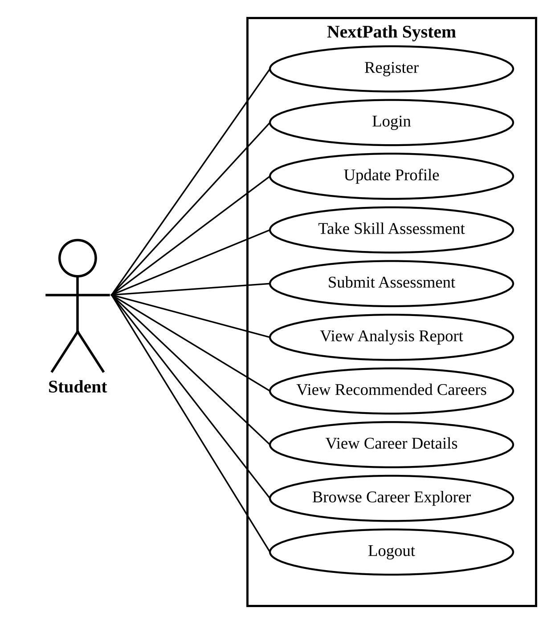
Figure 4.2: Use Case Diagram – Student
4.2 Normalization
Normalization is the process of organizing the columns (attributes) and tables (relations) of a relational database to reduce data redundancy and improve data integrity.
(A) De-normalized Form
User ID | User Name | Email | Education | College | Interests | Skills | Category
1 | poppy | poppy@gmail.com | Undergraduate | CZMG | Photography | Editing | Science
2 | moppy | moppy@gmail.com | Undergraduate | CZMG | Photography | Editing | Science

Career | Course | Skill | Question | Selected Answer | Assessment Score
Research Scientist | B.Sc in Physics / Chemistry / Biology | Analytical Thinking | Which activity interests you most? | A | 25
Lab Technician | M.Sc in a Core Science Discipline | Analytical Thinking | What excites you most about a school project? | B | 25
Software Engineer | B.E. / B.Tech | Problem Solving | Which activity interests you most? | A | 25

(B) First Normal Form (1NF)
1) Table Name: tbl_user
Primary Key: id (Auto Increment)
id | full_name | email | mobile | gender | education_level
1 | NEXTPath Admin | admin@nextpath.com | 98XXXXXXXX | Other | Graduate
3 | poppy | poppy@gmail.com | 91XXXXXXXX | Female | Undergraduate

college_name | interests | skills | hobbies | role
NEXTPath HQ | NULL | NULL | NULL | admin
CZMG | Photography | Editing | Sports | student

2) Table Name: tbl_categories
Primary Key: id (Auto Increment)
id | name | description
1 | Science | Explore careers built on scientific inquiry, experimentation and discovery.
2 | Accounting & Finance | Careers involving financial records, analysis, auditing and planning.
3 | Banking | Careers in retail and corporate banking, credit and financial services.
4 | Nursing & Healthcare | Careers focused on patient care, treatment and health services.

3) Table Name: tbl_careers
Primary Key: id (Auto Increment)
id | category_id | career_name | relevance
1 | 1 | Research Scientist | 1
2 | 1 | Lab Technician | 0.9
3 | 1 | Science Journalist | 0.75
4 | 2 | Accountant | 1
5 | 2 | Financial Analyst | 0.95
6 | 2 | Tax Consultant | 0.85

4) Table Name: tbl_courses
Primary Key: id (Auto Increment)
id | category_id | course_name | description
1 | 1 | B.Sc in Physics / Chemistry / Biology | A foundational science degree that opens the door to research, teaching and specialised M.Sc study.
2 | 1 | M.Sc in a Core Science Discipline | Advanced specialisation for students aiming at research or a doctoral pathway.
3 | 2 | B.Com (Accounting & Finance) | Covers financial accounting, auditing and taxation fundamentals.
4 | 2 | Chartered Accountancy (CA) / CMA | Professional certification for accounting, audit and cost management careers.

5) Table Name: tbl_category_skills
Primary Key: id (Auto Increment)
id | category_id | skill_name | weight
1 | 1 | Analytical Thinking | 1
2 | 2 | Analytical Thinking | 1
3 | 3 | Analytical Thinking | 1
4 | 4 | Communication | 1
5 | 5 | Creativity | 1
6 | 6 | Leadership | 1

6) Table Name: tbl_questions
Primary Key: id (Auto Increment)
id | category_id | question_text | option_a | option_b | option_c | option_d | correct_answer
1 | 1 | Which activity interests you most? | Running a controlled experiment | Preparing financial reports | Designing a marketing campaign | Managing a hotel front desk | A
2 | 1 | What excites you most about a school project? | Testing a hypothesis with real data | Sketching a poster for the event | Interviewing people for a story | Organising a sports tournament | A
3 | 2 | Which activity would you prefer? | Preparing financial reports | Designing websites | Treating patients | Creating animations | A

7) Table Name: tbl_assessments
Primary Key: id (Auto Increment)
id | user_id | total_questions | correct_answers | overall_score | completed_at
2 | 3 | 40 | 10 | 25 | 2026-09-05 11:42

8) Table Name: tbl_assessment_answers
Primary Key: id (Auto Increment)
id | assessment_id | question_id | selected_answer | is_correct | score
41 | 2 | 40 | A | 1 | 1
42 | 2 | 27 | B | 0 | 0
43 | 2 | 3 | B | 0 | 0
44 | 2 | 36 | B | 0 | 0
45 | 2 | 23 | A | 1 | 1

9) Table Name: tbl_settings
Primary Key: setting_key
setting_key | setting_value
assessment_length | 40

(C) Second Normal Form (2NF)
In 2NF every non-key attribute is fully dependent on the primary key. Repeating career, course, skill, question and answer data is moved into separate tables that are linked through foreign keys.
1) Table Name: tbl_user
Primary Key: id (Auto Increment)
id (PK) | full_name | email | mobile | gender | education_level
1 | NEXTPath Admin | admin@nextpath.com | 98XXXXXXXX | Other | Graduate
3 | poppy | poppy@gmail.com | 91XXXXXXXX | Female | Undergraduate

college_name | interests | skills | hobbies | role
NEXTPath HQ | NULL | NULL | NULL | admin
CZMG | Photography | Editing | Sports | student

2) Table Name: tbl_categories
Primary Key: id (Auto Increment)
id (PK) | name | description | created_at | updated_at
1 | Science | Explore careers built on scientific inquiry, experimentation and discovery. | 2026-07-10 | 2026-07-10
2 | Accounting & Finance | Careers involving financial records, analysis, auditing and planning. | 2026-07-10 | 2026-07-10
3 | Banking | Careers in retail and corporate banking, credit and financial services. | 2026-07-10 | 2026-07-10
4 | Nursing & Healthcare | Careers focused on patient care, treatment and health services. | 2026-07-10 | 2026-07-10

3) Table Name: tbl_careers
Primary Key: id (Auto Increment) Foreign Key: category_id
id (PK) | category_id (FK) | career_name | description | relevance
1 | 1 | Research Scientist | Designs and runs experiments to advance scientific knowledge. | 1
2 | 1 | Lab Technician | Supports experiments and maintains laboratory equipment. | 0.9
3 | 1 | Science Journalist | Communicates scientific findings to the public. | 0.75
4 | 2 | Accountant | Prepares and audits financial records for organisations. | 1
5 | 2 | Financial Analyst | Analyses financial data to guide investment decisions. | 0.95
6 | 2 | Tax Consultant | Advises individuals and businesses on tax planning. | 0.85

4) Table Name: tbl_courses
Primary Key: id (Auto Increment) Foreign Key: category_id
id (PK) | category_id (FK) | course_name | description
1 | 1 | B.Sc in Physics / Chemistry / Biology | A foundational science degree that opens the door to research, teaching and specialised M.Sc study.
2 | 1 | M.Sc in a Core Science Discipline | Advanced specialisation for students aiming at research or a doctoral pathway.
3 | 2 | B.Com (Accounting & Finance) | Covers financial accounting, auditing and taxation fundamentals.
4 | 2 | Chartered Accountancy (CA) / CMA | Professional certification for accounting, audit and cost management careers.
5 | 3 | B.Com with Banking & Insurance | Focused commerce degree covering banking operations and financial services.
6 | 3 | Diploma in Banking & Finance | A shorter, practice-oriented path into retail and corporate banking roles.

5) Table Name: tbl_category_skills
Primary Key: id (Auto Increment) Foreign Key: category_id
id (PK) | category_id (FK) | skill_name | weight
1 | 1 | Analytical Thinking | 1
2 | 2 | Analytical Thinking | 1
3 | 3 | Analytical Thinking | 1
4 | 4 | Communication | 1

6) Table Name: tbl_questions
Primary Key: id (Auto Increment) Foreign Key: category_id
id (PK) | category_id (FK) | question_text | option_a | option_b | option_c | option_d | correct_answer
1 | 1 | Which activity interests you most? | Running a controlled experiment | Preparing financial reports | Designing a marketing campaign | Managing a hotel front desk | A
2 | 1 | What excites you most about a school project? | Testing a hypothesis with real data | Sketching a poster for the event | Interviewing people for a story | Organising a sports tournament | A
3 | 2 | Which activity would you prefer? | Preparing financial reports | Designing websites | Treating patients | Creating animations | A
4 | 2 | What sounds most satisfying to you? | Reconciling a company's accounts | Coaching a football team | Writing a news article | Designing a building facade | A

7) Table Name: tbl_assessments
Primary Key: id (Auto Increment) Foreign Key: user_id
id (PK) | user_id (FK) | total_questions | correct_answers | overall_score | completed_at
2 | 3 | 40 | 10 | 25 | 2026-09-05 11:42

8) Table Name: tbl_assessment_answers
Primary Key: id (Auto Increment) Foreign Key: assessment_id, question_id
id (PK) | assessment_id (FK) | question_id (FK) | selected_answer | is_correct | score
41 | 2 | 40 | A | 1 | 1
42 | 2 | 27 | B | 0 | 0
43 | 2 | 3 | B | 0 | 0
44 | 2 | 36 | B | 0 | 0
45 | 2 | 23 | A | 1 | 1
46 | 2 | 29 | A | 1 | 1
47 | 2 | 38 | C | 0 | 0
48 | 2 | 15 | D | 0 | 0

9) Table Name: tbl_settings
Primary Key: setting_key
setting_key (PK) | setting_value
assessment_length | 40

4.3 E-R Diagram
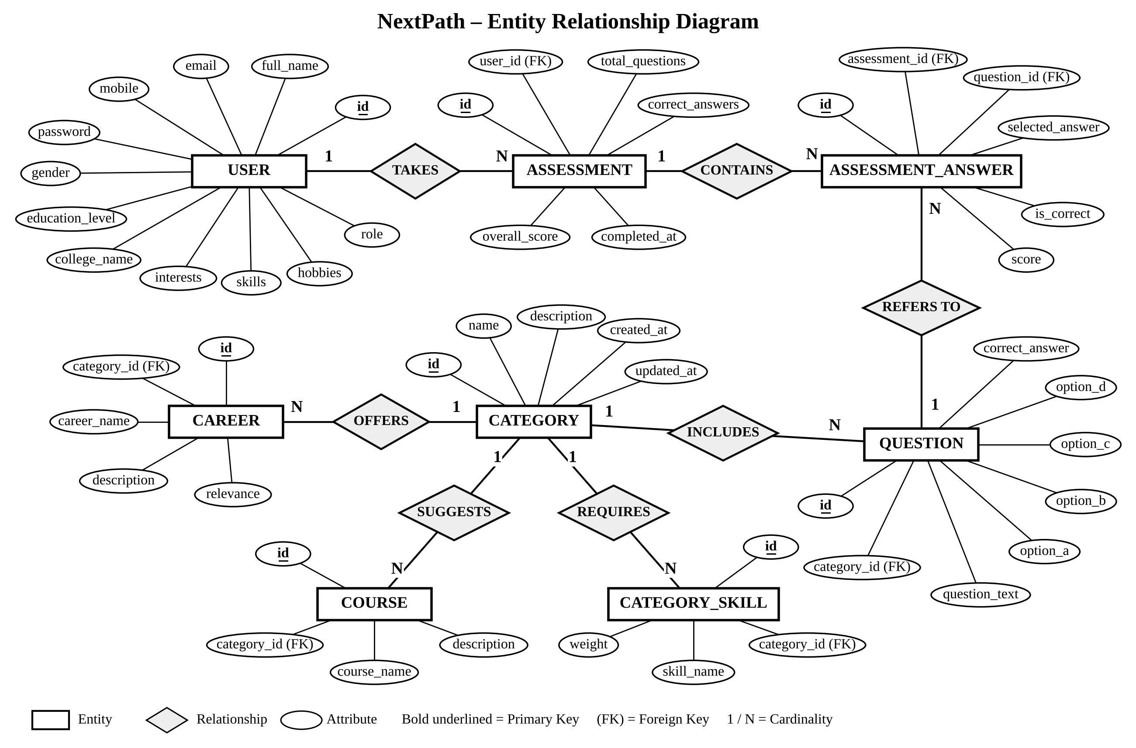
Figure 4.3: E-R Diagram of NextPath (Chen Notation)

4.4 Data Dictionary
1. tbl_user
Field Name | Data Type | Key | Description
id | INT | PK | Unique identifier of the user
full_name | VARCHAR |  | Full name of the user
email | VARCHAR |  | Email address used for login; must be unique
mobile | VARCHAR |  | Mobile number (up to 10 digits)
password | VARCHAR |  | One-way hashed password
gender | VARCHAR |  | Male / Female / Other (optional)
education_level | VARCHAR |  | High School, Higher Secondary, Undergraduate, Graduate or Postgraduate (optional)
college_name | VARCHAR |  | School / college name (optional)
interests | VARCHAR |  | Interests of the student (optional)
skills | VARCHAR |  | Skills of the student (optional)
hobbies | VARCHAR |  | Hobbies of the student (optional)
role | ENUM |  | 'student' or 'admin'

2. tbl_categories
Field Name | Data Type | Key | Description
id | INT | PK | Unique identifier of the category
name | VARCHAR |  | Career category name (28 categories)
description | TEXT |  | Short description shown on the home page and explorer
created_at | DATETIME |  | Date and time the record was created
updated_at | DATETIME |  | Date and time the record was last updated

3. tbl_questions
Field Name | Data Type | Key | Description
id | INT | PK | Unique identifier of the question
category_id | INT | FK | Category to which the question belongs (tbl_categories.id)
question_text | VARCHAR |  | Question statement
option_a – option_d | VARCHAR |  | Four multiple-choice options
correct_answer | VARCHAR |  | Correct option used for scoring

4. tbl_assessments
Field Name | Data Type | Key | Description
id | INT | PK | Unique identifier of the assessment attempt
user_id | INT | FK | Student who took the assessment (tbl_user.id)
total_questions | INT |  | Number of questions in the attempt
correct_answers | INT |  | Number of correct answers
overall_score | DECIMAL |  | Correct answers ÷ total questions × 100
completed_at | DATETIME |  | Time of the attempt, shown in history and log

5. tbl_assessment_answers
Field Name | Data Type | Key | Description
id | INT | PK | Unique identifier of the stored answer
assessment_id | INT | FK | Assessment attempt to which the answer belongs (tbl_assessments.id)
question_id | INT | FK | Question that was answered (tbl_questions.id)
selected_answer | VARCHAR |  | Option chosen by the student
is_correct | TINYINT |  | 1 if the selected answer is correct, otherwise 0
score | INT |  | Score awarded for the answer

6. tbl_careers
Field Name | Data Type | Key | Description
id | INT | PK | Unique identifier of the career
category_id | INT | FK | Category of the career (tbl_categories.id)
career_name | VARCHAR |  | Name of the career (84 careers)
description | TEXT |  | Short description of the career
relevance | DECIMAL |  | Weight from 0 to 1 used in the career match

7. tbl_courses
Field Name | Data Type | Key | Description
id | INT | PK | Unique identifier of the course
category_id | INT | FK | Category for which the course is suggested (tbl_categories.id)
course_name | VARCHAR |  | Suggested course or degree (56 courses)
description | TEXT |  | Short description of the course

8. tbl_category_skills
Field Name | Data Type | Key | Description
id | INT | PK | Unique identifier of the mapping
category_id | INT | FK | Category contributing to a skill (tbl_categories.id)
skill_name | VARCHAR |  | Skill of the Skill Profile (e.g. Communication)
weight | DECIMAL |  | Weight of the category in the skill calculation

4.5 Functional and Behavior Modeling
4.5.1 Context Diagram (0-Level Diagram)
The context diagram shows the complete NextPath system as a single process (0.0) and the data that flows between the system and its two external entities – the Student and the Administrator.
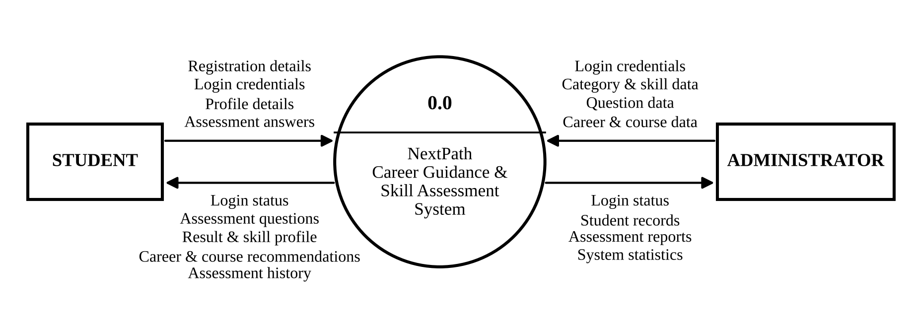
Figure 4.4: Context Diagram (0-Level DFD)
Symbols used in the DFD:
Symbol | Name | Meaning
Rectangle | External Entity | A person outside the system that sends or receives data (Student, Administrator)
Circle | Process | Work done on data, numbered 0.0, 1.0, 2.0 …
Open-ended rectangle | Data Store | Place where data is stored; shown as D1, D2 … with the table name
Arrow | Data Flow | Direction in which the named data moves

4.5.2 First Level Diagram (1-Level Diagram)
In the 1-level DFD the single process of the context diagram is broken into its main sub-processes. Each data store is labelled D1 to D8; every data store is one table of the NextPath database, as listed below. The same numbers are used in both the Administrator and Student diagrams.
Data Store | Table Name | Data Stored
D1 | tbl_user | Student and administrator accounts and profiles
D2 | tbl_categories | Career categories
D3 | tbl_questions | Assessment questions with options and correct answer
D4 | tbl_careers | Careers under each category
D5 | tbl_courses | Courses suggested for each category
D6 | tbl_category_skills | Skill weights of each category
D7 | tbl_assessments | Assessment attempts and scores
D8 | tbl_assessment_answers | Answers given in each attempt

(a) Administrator
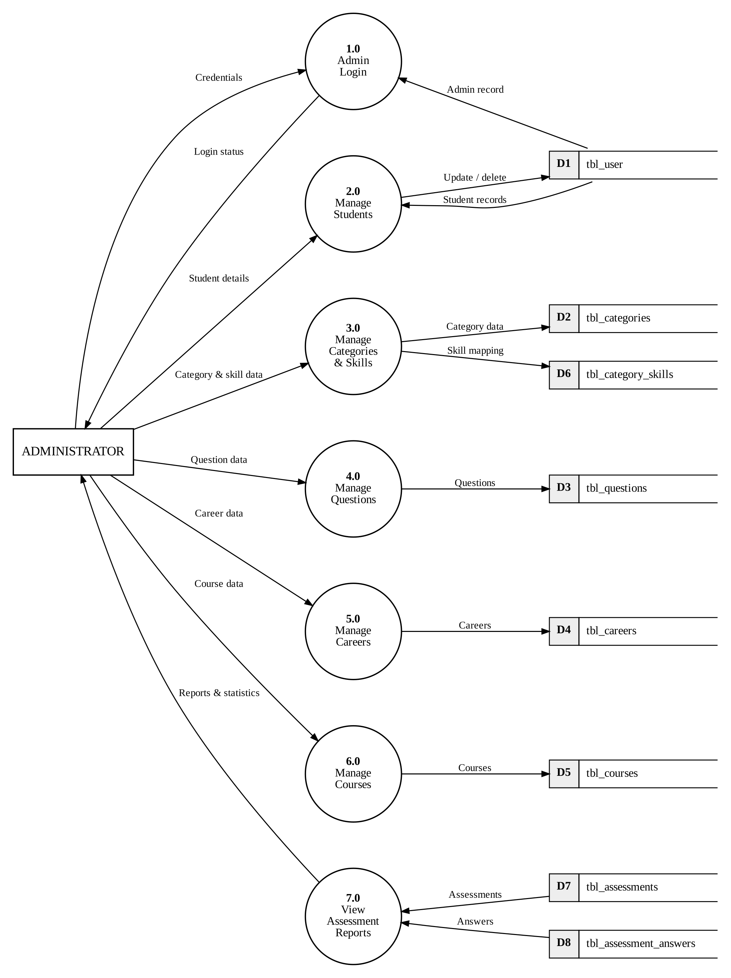
Figure 4.5: 1-Level DFD – Administrator

(b) User / Student
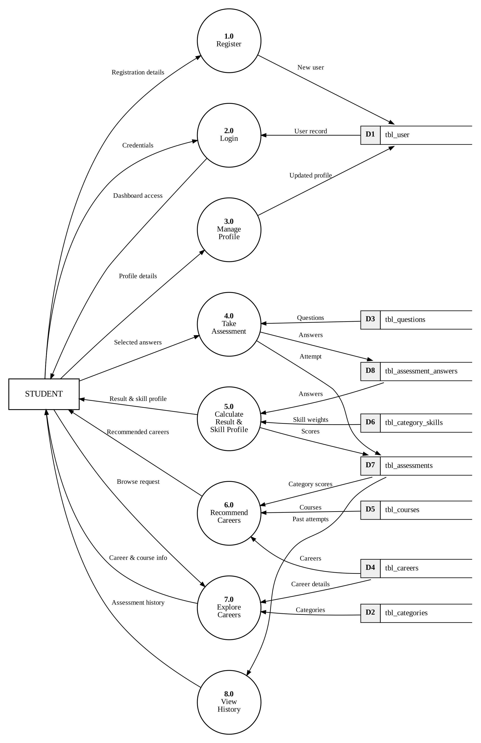
Figure 4.6: 1-Level DFD – Student
4.6 Gantt Chart
The Gantt chart below compares the expected time (blue) and the actual time (green) taken for each phase of the project from July to October 2026.
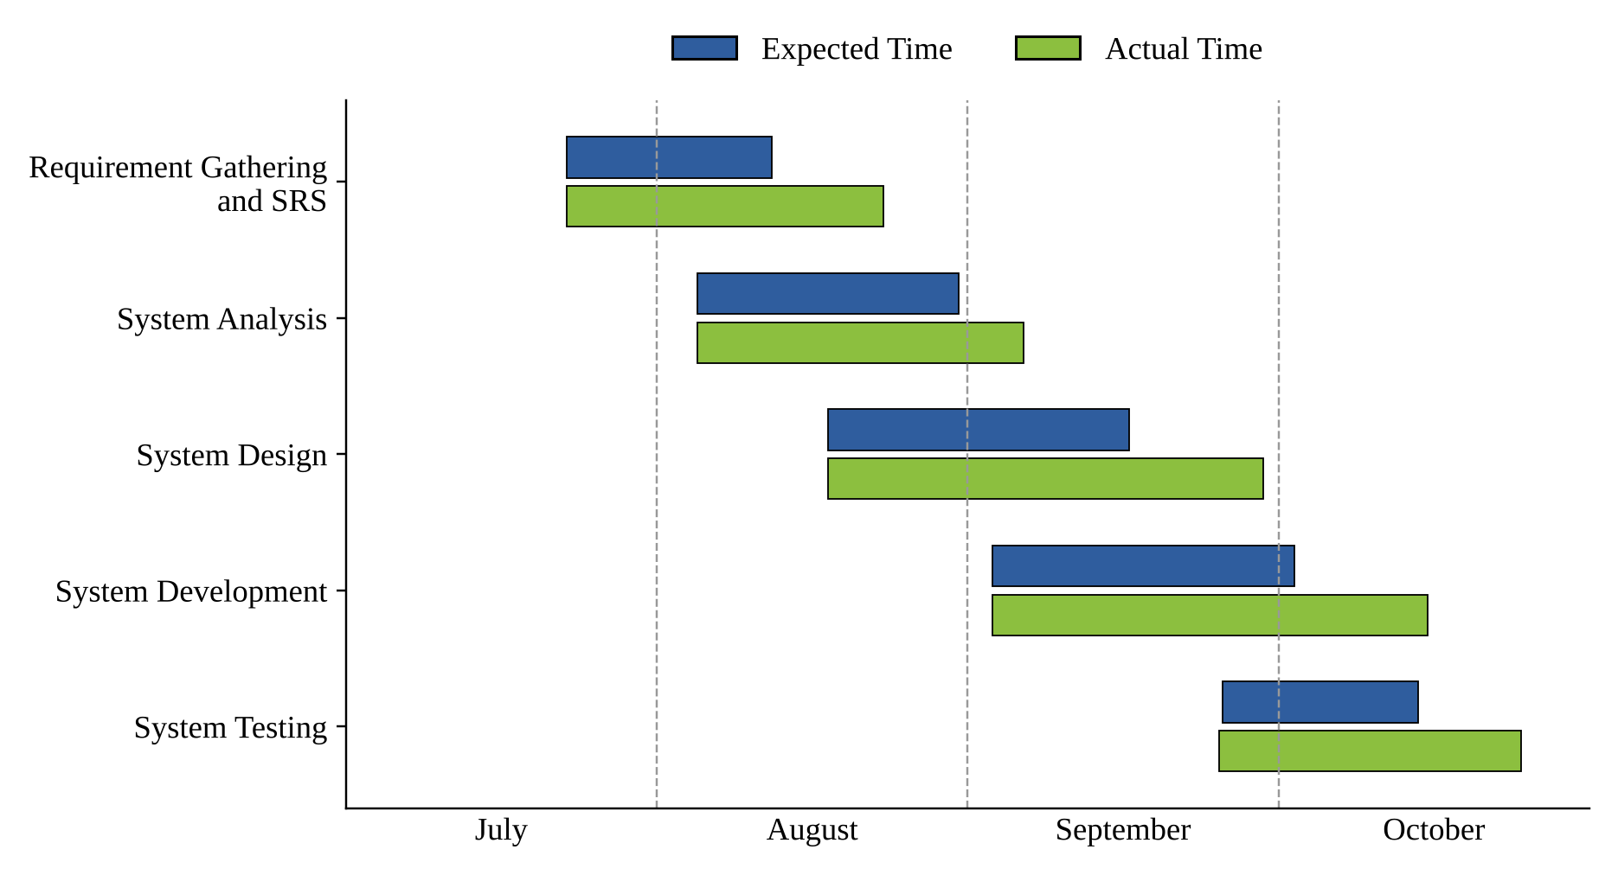
Figure 4.7: Gantt Chart
5. TEST CASES
Invalid Login
TEST CASE No.: 1 |  |  | TEST CASE DESIGN DATE: 20/07/2026
TEST TITLE: Invalid Login Test |  |  | TEST CASE EXECUTION DATE: 05/08/2026
DESCRIPTION: In this test case the invalid login handling of the Login module is tested.
PRECONDITION: Login page must be working.
Step No. | Test Step | Test Data | Expected Result | Actual Result | Status
1 | Submit empty email and password | Blank | Messages "Please enter a valid email address." and "Please enter your password." are displayed. | Same as expected | PASS
2 | Enter a wrong password | Valid email, wrong password | Message "Incorrect email or password." is displayed. | Same as expected | PASS
3 | Enter an unregistered email | Unknown email | Message "Incorrect email or password." is displayed and no session is created. | Same as expected | PASS

Login
TEST CASE No.: 2 |  |  | TEST CASE DESIGN DATE: 15/08/2026
TEST TITLE: Login Test |  |  | TEST CASE EXECUTION DATE: 25/08/2026
DESCRIPTION: In this test case the Login module is tested.
PRECONDITION: Login page must be working.
Step No. | Test Step | Test Data | Expected Result | Actual Result | Status
1 | Open login.php | – | Login form with Email and Password fields and Show toggle is displayed. | Same as expected | PASS
2 | Login with valid student credentials | Student email and password | Session is created and student dashboard opens. | Same as expected | PASS
3 | Login with valid admin credentials | Admin email and password | Session is created and admin dashboard opens. | Same as expected | PASS
4 | Open login.php while logged in | – | User is redirected to the dashboard according to their role. | Same as expected | PASS

Skill Assessment Attempt
TEST CASE No.: 3 |  |  | TEST CASE DESIGN DATE: 31/08/2026
TEST TITLE: Skill Assessment Attempt Test |  |  | TEST CASE EXECUTION DATE: 05/09/2026
DESCRIPTION: Verify the skill assessment attempt with mixed-category questions.
PRECONDITION: Student must be logged in and the question bank must contain questions.
Step No. | Test Step | Test Data | Expected Result | Actual Result | Status
1 | Click Start Assessment | – | First question is displayed in the one-question interface. | Same as expected | PASS
2 | Select an option and click Next | Any option | Next question is displayed and the progress bar advances. | Same as expected | PASS
3 | Click Previous | – | Previous question is displayed with the earlier selection retained. | Same as expected | PASS
4 | Observe the question order | – | Questions from different categories are mixed rather than grouped. | Same as expected | PASS

Assessment Submission and Score Calculation
TEST CASE No.: 4 |  |  | TEST CASE DESIGN DATE: 15/09/2026
TEST TITLE: Assessment Submission and Score Calculation Test |  |  | TEST CASE EXECUTION DATE: 30/09/2026
DESCRIPTION: Verify assessment submission and calculated scores.
PRECONDITION: All assessment questions must be attempted.
Step No. | Test Step | Test Data | Expected Result | Actual Result | Status
1 | Submit the assessment | All answers selected | Each answer is stored with its correctness in tbl_assessment_answers. | Same as expected | PASS
2 | Check overall score | 30 correct out of 40 | Overall score is calculated as 75%. | Same as expected | PASS
3 | Check category score | 3 correct out of 4 | Category score is calculated as 75%. | Same as expected | PASS
4 | Check skill profile and strengths | Category scores | Skill scores are calculated and strongest areas are ranked. | Same as expected | PASS

6. SCREENSHOTS
6.1 Home Page
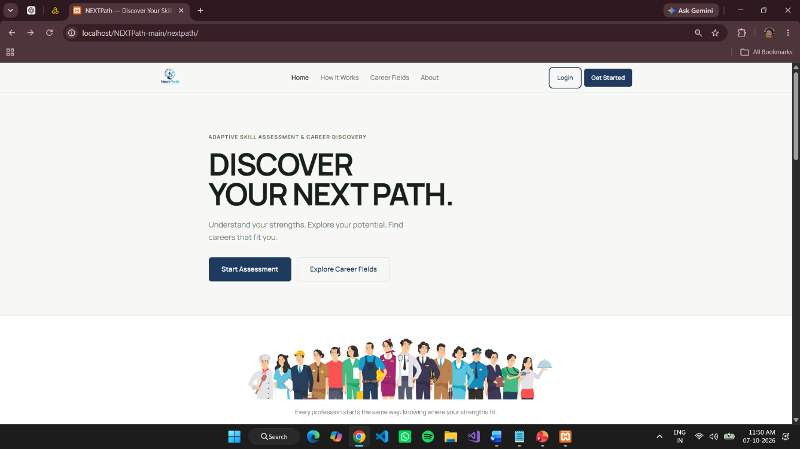
Figure 6.1: Home Page
6.2 Student Registration Page
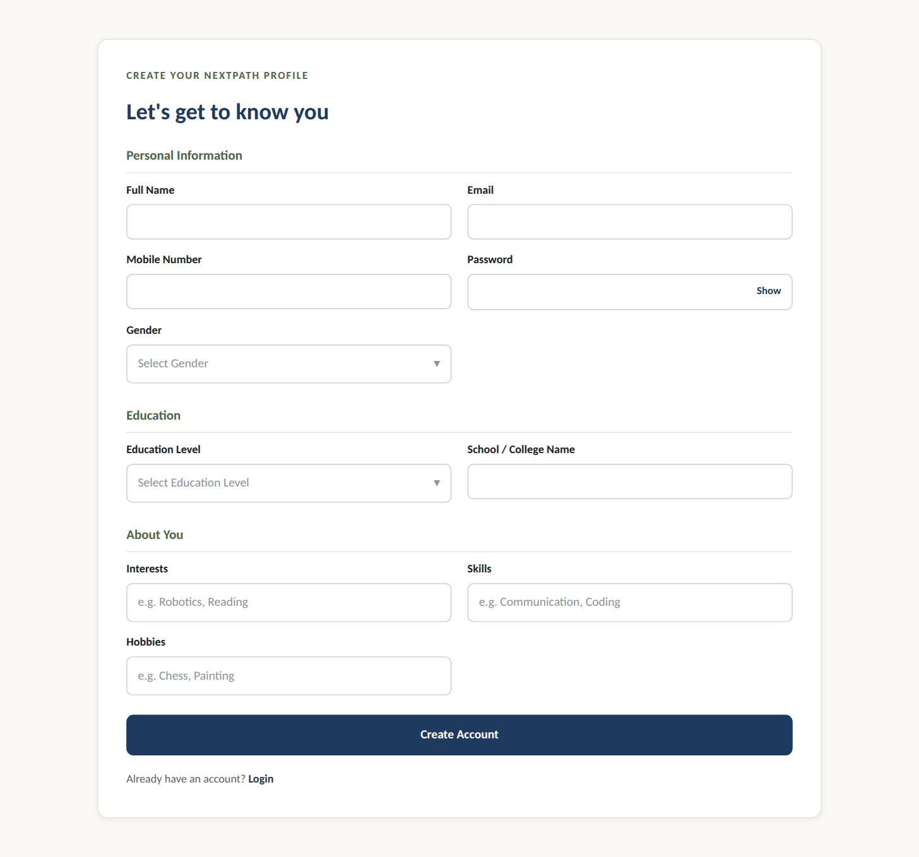
Figure 6.2: Student Registration Page
6.3 Login Page
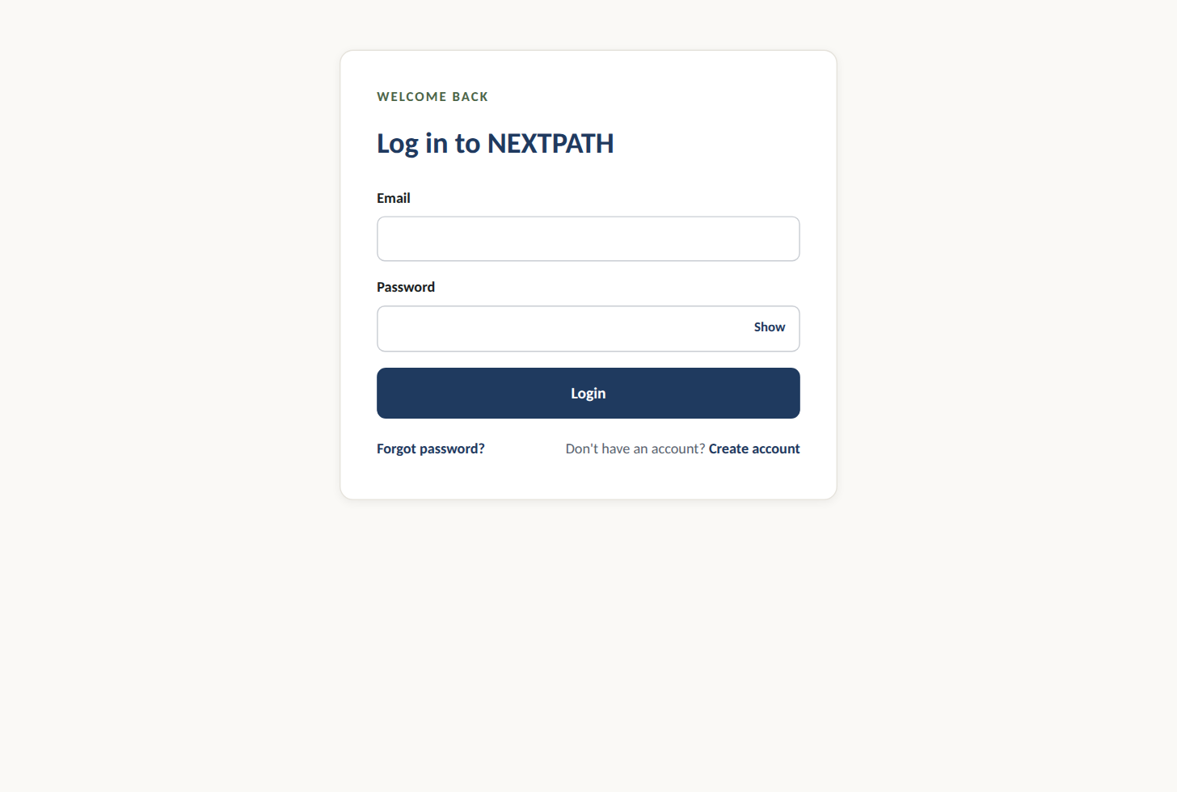
Figure 6.3: Login Page
6.4 Student Dashboard Page
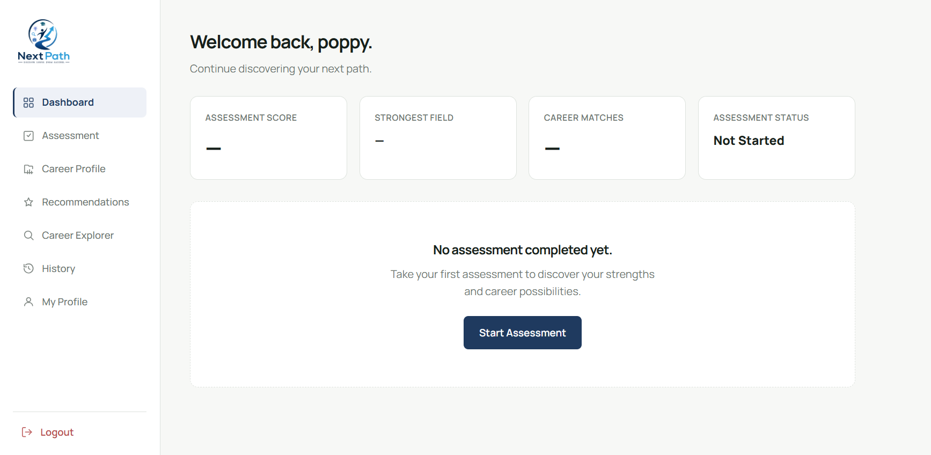
Figure 6.4: Student Dashboard Page
6.5 Student Assessment Page
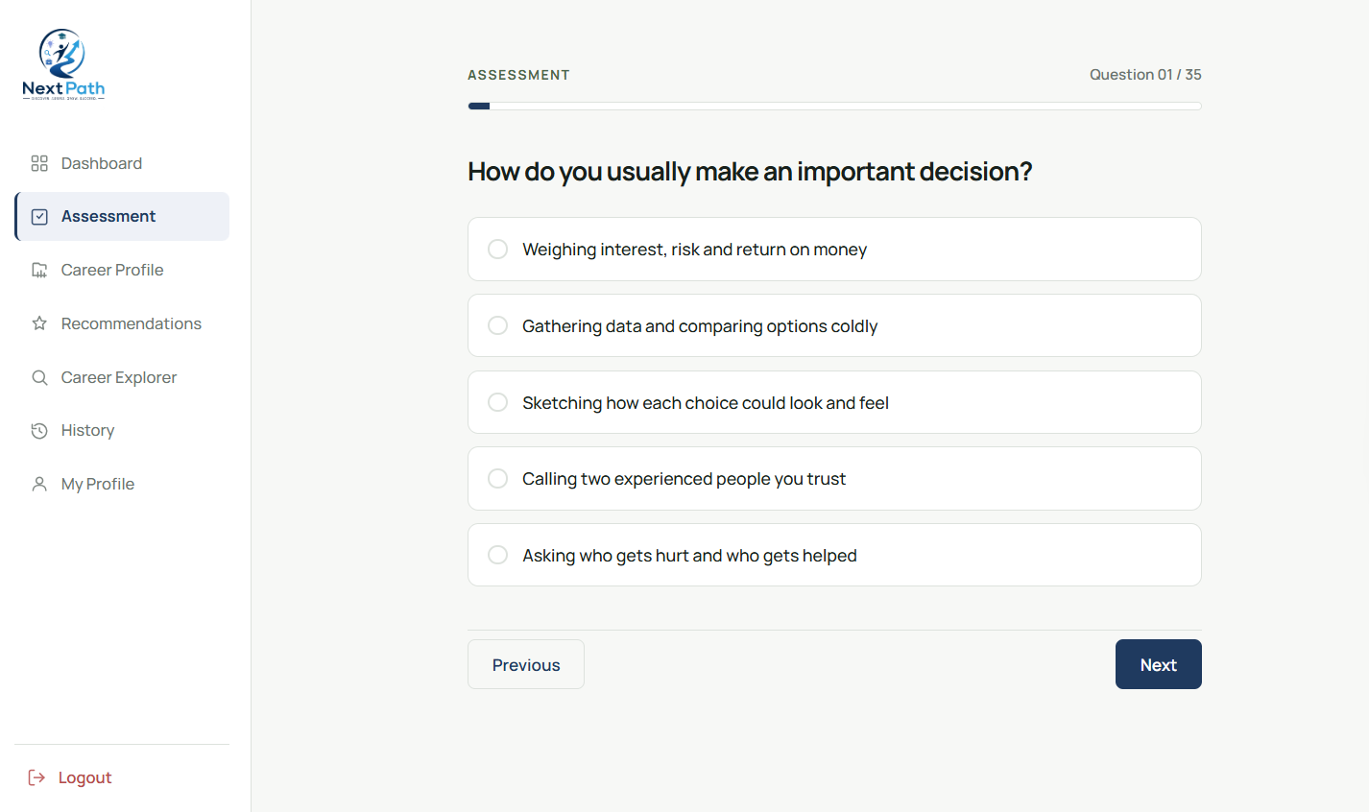
Figure 6.5: Student Assessment Page
6.6 Student Career Explorer Page
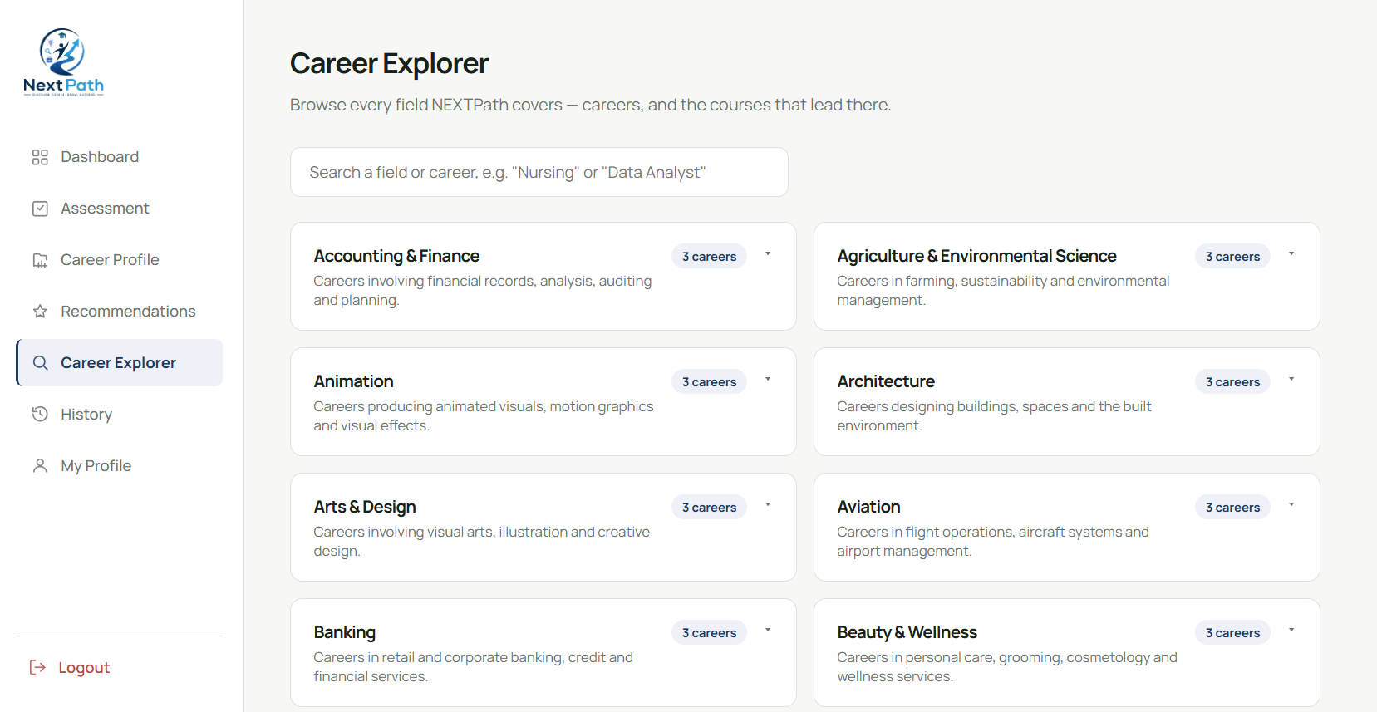
Figure 6.6: Student Career Explorer Page
6.7 Student Assessment Result Page
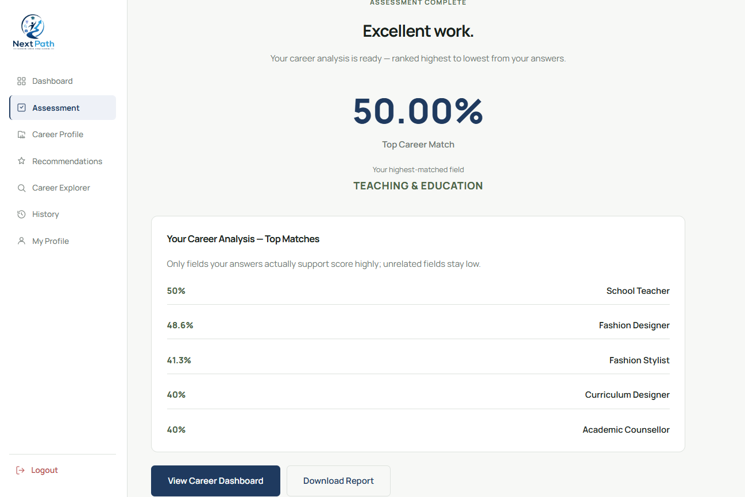
Figure 6.7: Student Assessment Result Page
6.8 Student Career Dashboard Page
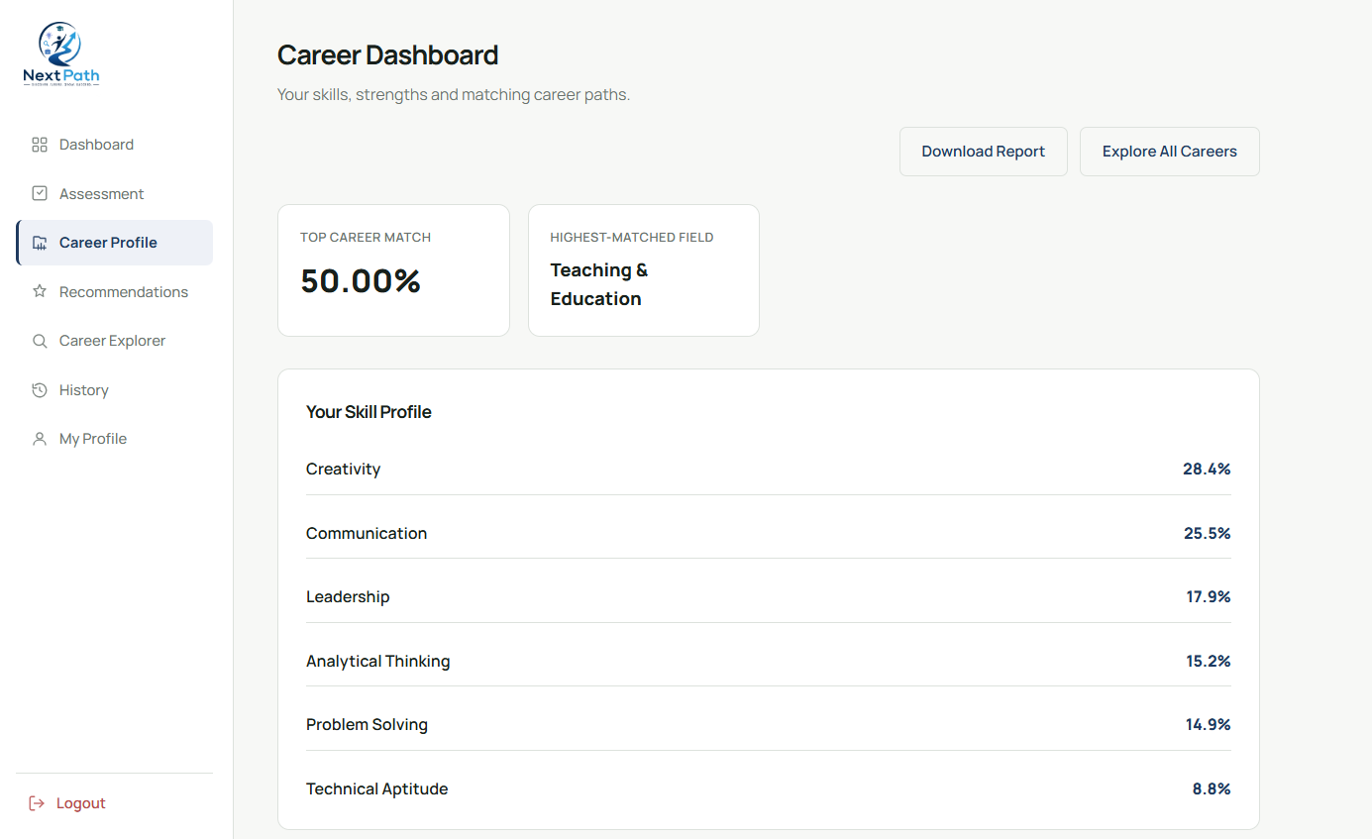
Figure 6.8: Student Career Dashboard Page
6.9 Student Recommended Career Page
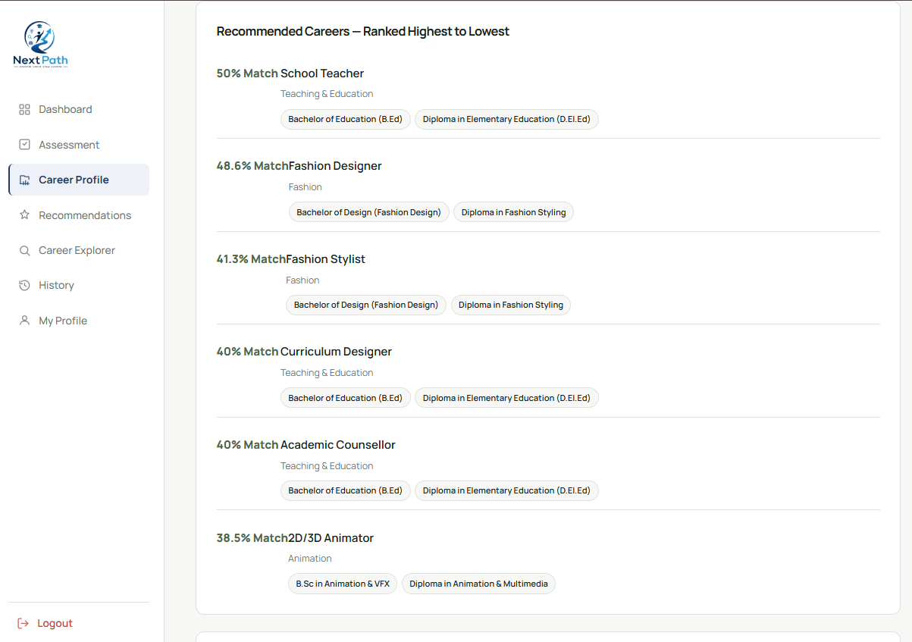
Figure 6.9: Student Recommended Career Page
6.10 Student Assessment History Page
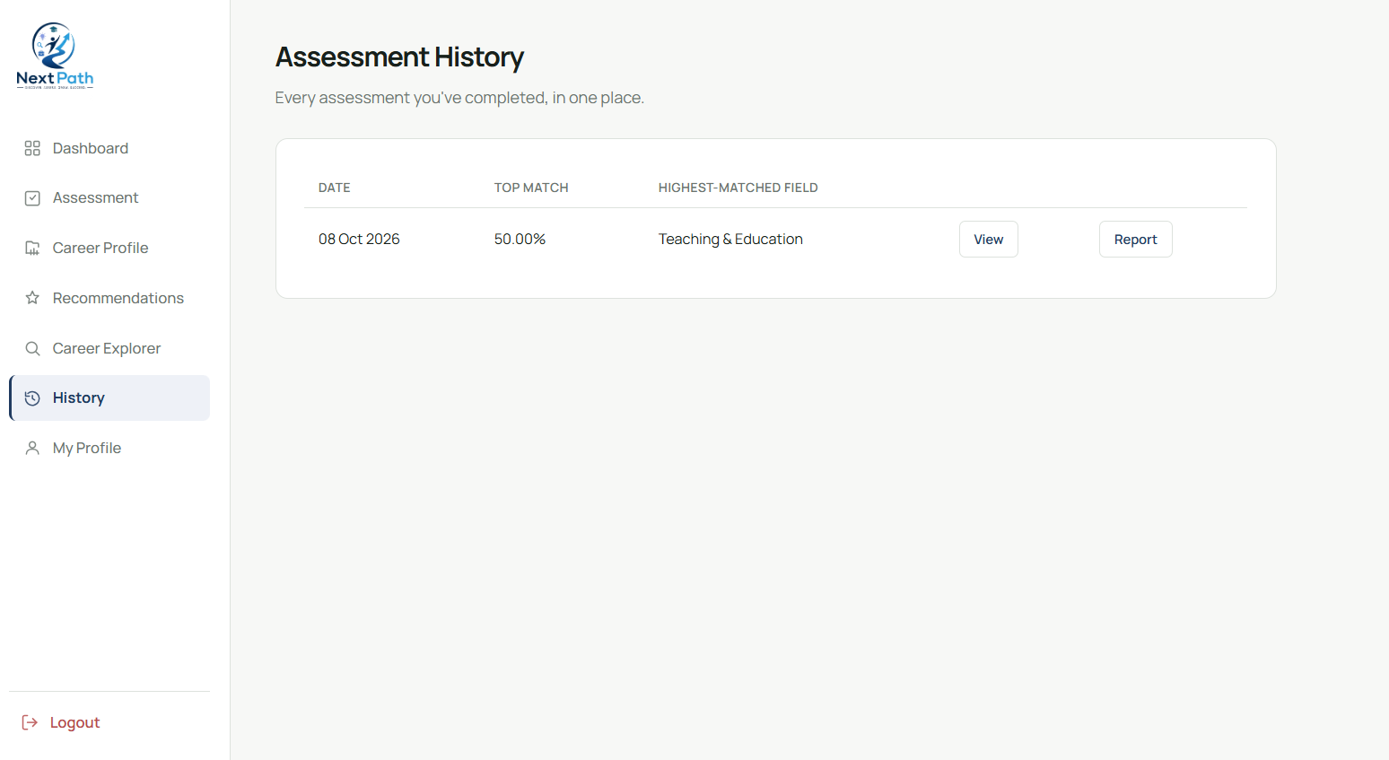
Figure 6.10: Student Assessment History Page
6.11 Student Profile Page
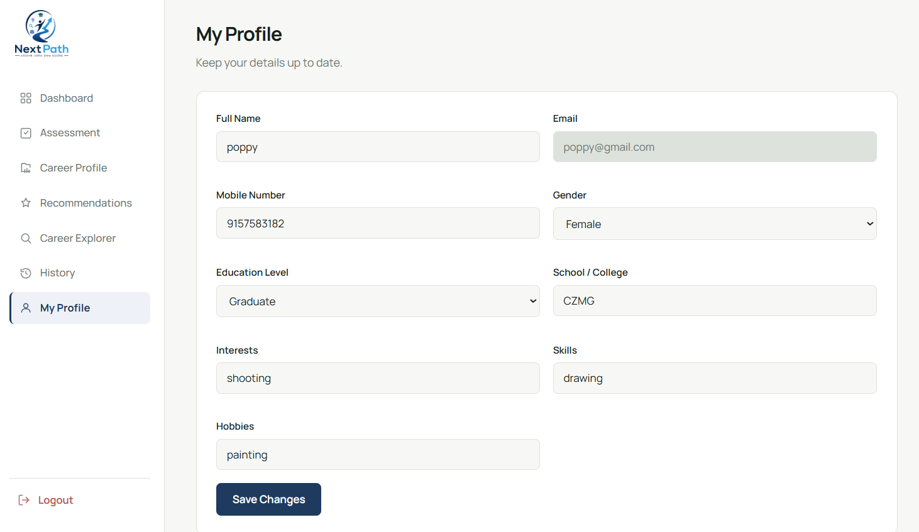
Figure 6.11: Student Profile Page
7. CODE EXPLANATION
7.1 Database Configuration
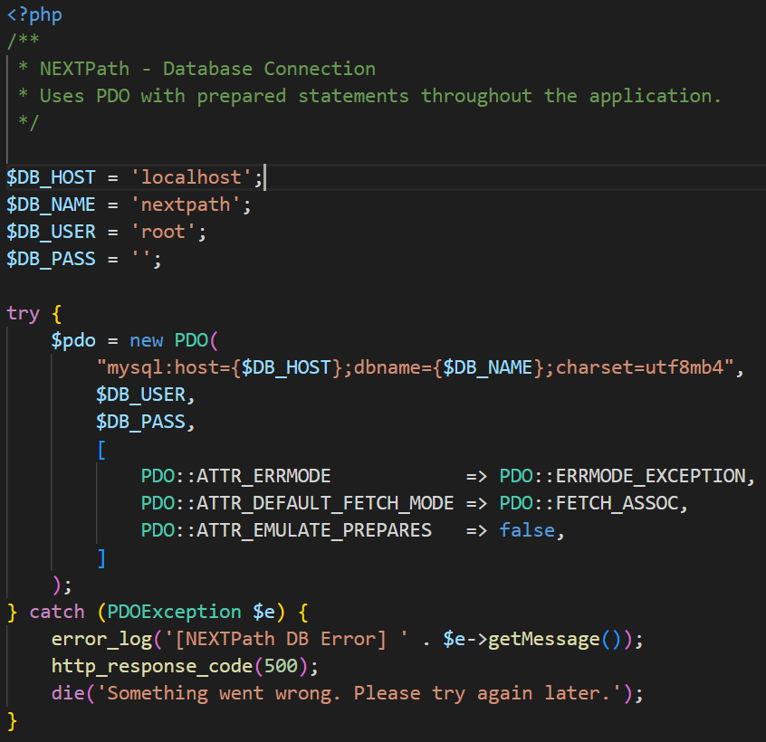
Explanation:
- Database Connection Setup – Defines the database credentials (host, database name, username, password) and establishes the connection between PHP and MySQL using new PDO().
- Error Handling & Security – Wraps the connection logic in a try-catch block to hide raw database errors from users and disables emulated prepares (PDO::ATTR_EMULATE_PREPARES => false) for native, secure prepared queries.
- Data Fetching Configuration – Configures PDO::FETCH_ASSOC as the default fetch mode so records are retrieved as clean associative arrays for easier handling in PHP.

7.2 Login Page
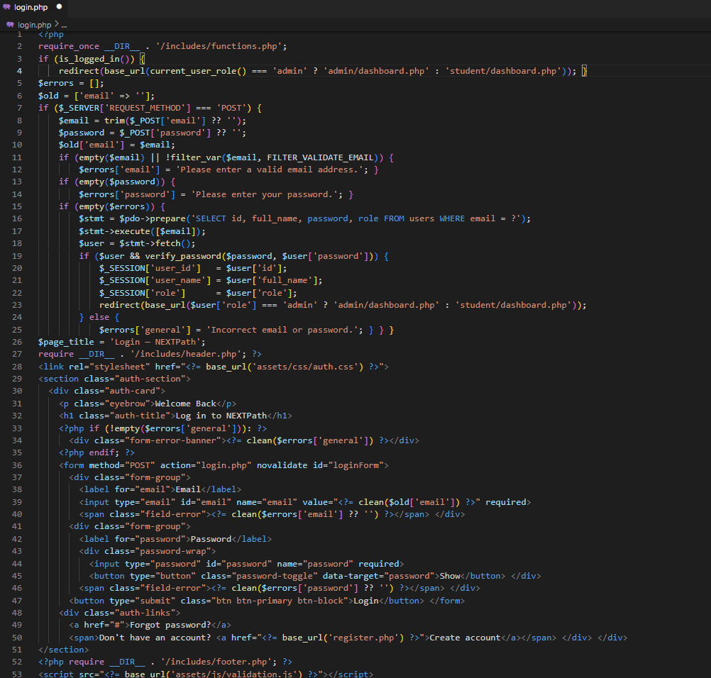
Explanation:
- User Authentication & Validation – Validates that the submitted email format is valid and the password field is not empty, enabling registered users to log in securely.
- Database Verification & Password Hashing – Searches for the user's email in the users table through a secure prepared SQL statement and verifies the credentials using password_verify().
- Session Management & Role Redirection – Saves the user's ID, name and role into the PHP session upon successful login and redirects administrators to the Admin Dashboard and students to the Student Dashboard.

7.3 Privacy Page
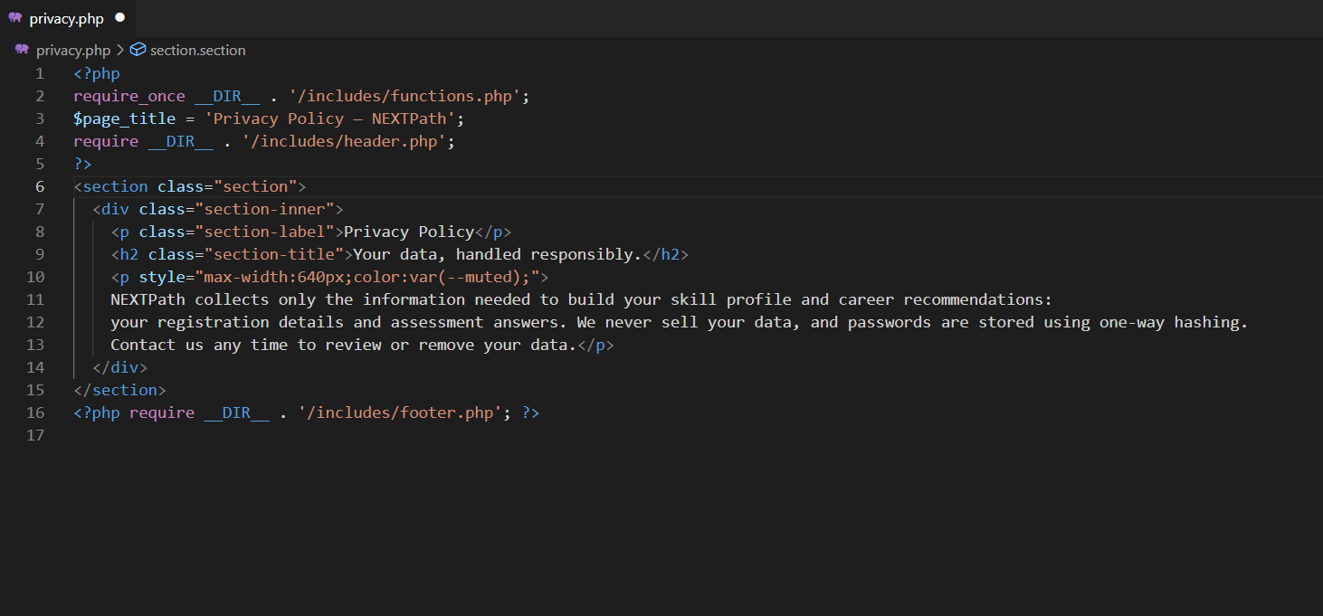
Explanation:
- Page Purpose & Structure – Serves as NextPath's static public privacy policy page, importing functions.php for helper utilities, setting the browser $page_title and maintaining UI consistency through shared header and footer templates.
- Data Usage & Protection – Clarifies that collected information (registration details and assessment answers) is used only to generate skill profiles and career recommendations, with an explicit guarantee that user data is never sold.
- Security & User Rights – Stores passwords using one-way hashing and gives users full ownership to review or request removal of their data at any time.

7.4 Index Page
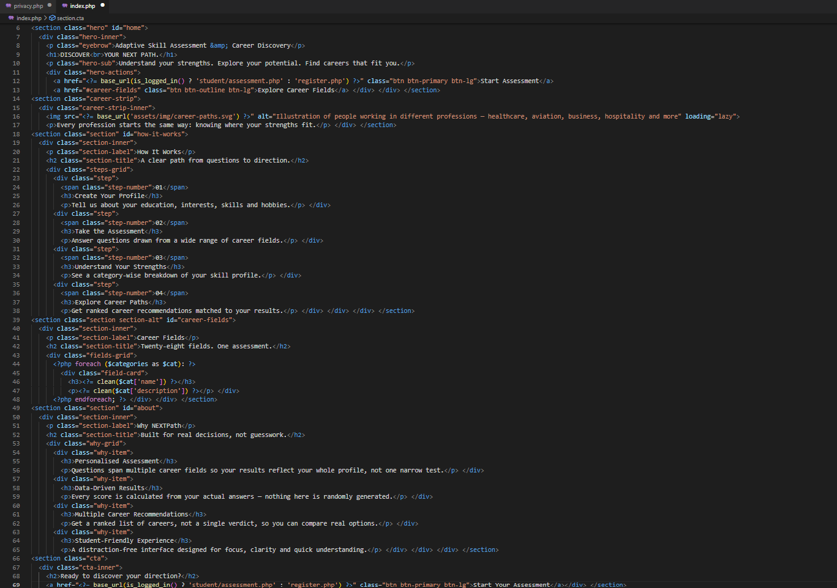
Explanation:
- Hero Section & Dynamic CTA – Introduces the NextPath career assessment platform and uses is_logged_in() to send logged-in users directly to student/assessment.php while routing guests to register.php.
- Step-by-Step Workflow & Value Proposition – Outlines the 4-step assessment journey (profile creation, test, strength breakdown, ranked careers) and highlights core platform benefits such as data-driven scoring and a distraction-free UI.
- Dynamic Career Categories & Secondary CTA – Renders career category cards by looping over $categories with clean() for XSS protection, closing with a bottom call-to-action banner to begin the assessment.

7.5 Logout Page
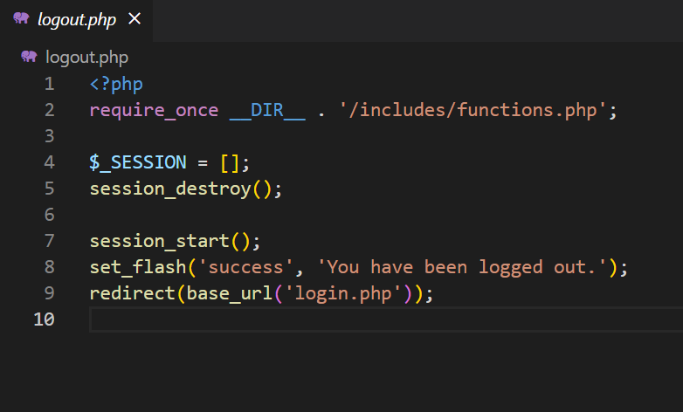
Explanation:
- Loads Helper Functions (require_once) – Imports essential utility functions from functions.php (such as flash messaging and redirect helpers) using the absolute directory path __DIR__.
- Clears and Destroys the Active Session – Empties the $_SESSION array with $_SESSION = [] and destroys the server-side session data using session_destroy().
- Sets a Flash Message and Redirects – Starts a fresh session with session_start() only to store the confirmation message "You have been logged out." through set_flash(), then sends the user to login.php using redirect().
8. LIMITATIONS AND FUTURE ENHANCEMENT
8.1 Limitations
- The assessment uses a predefined question bank; the quality of the results depends on the questions entered by the administrator.
- Recommendations are rule-based and use stored relevance weights; no machine-learning model is used.
- The career and course data are limited to the data stored in the database (28 categories, 84 careers and 56 courses) and are not updated from external sources.
- Password reset by email is not available.
- Administrator tables do not use pagination, which may be inconvenient with very large data.
- The Career Report depends on the browser's print-to-PDF function.
- The system is a web application only; there is no separate mobile application.
8.2 Future Enhancement
The following are possible future enhancements and are not part of the current system:
- Password reset through email.
- Pagination on large administrator tables.
- Configurable skill-to-category weighting from the Admin Dashboard.
- Export of assessment history to PDF.
- Multi-language support.
- A larger career and course database with more assessment categories.
- Improved or AI/ML-based recommendation logic and personalised learning paths.
- Integration of career trends and external job or internship information.
- A mobile application and notifications.
9. CONCLUSION
NextPath is a secure web-based skill assessment platform designed to help students discover suitable careers.
- Core Functionality: Students take a mixed-category multiple-choice test to receive scores, a skill profile, strength analysis and ranked career and course recommendations based on rule-based weighted logic.
- Admin Module: Enables dynamic management of questions, categories, careers and courses, along with student records and assessment analytics, without modifying code.
- Tech Stack & Security: Built using HTML5, CSS3, JavaScript, PHP (PDO) and MySQL, and secured with password hashing, prepared statements, output escaping and role-based access control.
- Future Scope: Expanding the career database, adding advanced analytics, mobile app support and password recovery features.
10. REFERENCES AND BIBLIOGRAPHY
Books
- Luke Welling and Laura Thomson, PHP and MySQL Web Development, Addison-Wesley.
- Roger S. Pressman, Software Engineering: A Practitioner's Approach, McGraw-Hill.
- Ramez Elmasri and Shamkant B. Navathe, Fundamentals of Database Systems, Pearson.
Technologies and Libraries
- PHP (with PDO) – server-side scripting language.
- MySQL / MariaDB – relational database.
- HTML5, CSS3 and JavaScript – front-end technologies.
- XAMPP (Apache, MySQL, phpMyAdmin) – local server environment.
Websites
- https://www.php.net/manual – PHP Manual
- https://dev.mysql.com/doc – MySQL Documentation
- https://www.w3schools.com – Web development tutorials
- https://www.apachefriends.org – XAMPP
- https://fonts.google.com – Google Fonts

